All preparations MUST be done BEFORE the technician arrives to do service.

BED BUG PREPARATION INSTRUCTIONS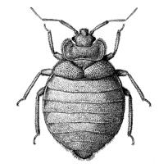

- You and your pet (if any) must leave your residence for a minimum of 4 hours once we start the treatment.

- Strip the mattress and box spring of all linens (If you have a bed bug cover in good condition, leave it on the mattress and box spring).
- Mattress and box spring must be lifted off the bed frame and turned onto its side.

- Drawers in the nightstand and dresser MUST be emptied.

- Clear floors of materials (toys, clothes, shoes, etc.)

- All pictures and art from the walls MUST be removed and sealed in plastic bags.

- Closets MUST be emptied.

- Clothes MUST be washed in hot water and dry clothes in hot heat or taken to dry cleaners. (Follow instructions on clothing tags for proper care).

- Shoes MUST be in a bag.

- Items can be put back in place once product has dried.

- If you do not already own a bed bug cover for your mattress and box spring, we highly recommend purchasing one.

- If you have a fish tank, make sure the aquarium pump is turned OFF, and the tank should be covered. If possible the HVAC system should be turned OFF until you return and ventilate your home. Please make every effort to ventilate your home by opening windows BEFORE technician arrives to your home.

